**Lab #1 - Python Essentials**

The notebook should be well organized. Each section should be **clearly labeled with the exercise (and part) that it addresses** (e.g., Exercise #1a, #1b, #2) in a Markdown cell block. Use (clear and concise) comments as needed to help describe each step of your process. All notebook cells that contain essential steps should be executed and the output should be visible, so as to demonstrate your successful completion of the exercise. If you cannot complete an exercise in its entirety, you should make an effort to demonstrate your intermediate progress in order to maximize partial credit, and move forward as best as possible. You may submit any written answers to the exercises in the notebook as text cells.

**Exercise #1 (1.5 points)**

You may recall from prior coursework that in statistics, a confidence interval is a range of values defined such that there is a specified probability that the value of a parameter lies within the interval. The expression for computing a confidence interval for the (population) mean is:

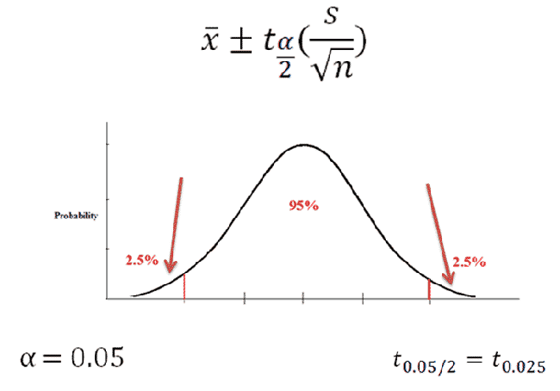

where x bar is the mean, t is the critical t value at confidence level alpha, s is the standard deviation, and n is the sample size.

In order to calculate the confidence interval bounds, we need to determine the appropriate value for the t-multiple. In the SciPy (scipy) module, there is a function stats.t that contains various methods for working with the t-distribution. In particular, there is a .ppf method that is used to determine specific quantiles of the distribution for a given sample size (n, or degrees of freedom, n - 1). The function takes in a quantile (q) and a degrees of freedom (df), and (by default), returns the value for which F(x) = q, where F is the cumulative distribution function (cdf). For this exercise, assume a assume a sample size **n = 30**.

**Step 1.1:** Define three parameters (variables) from the confidence interval formula **n**, **alpha**, and **q** where q = 1 - alpha/2. In the following steps, these variables will be used to calculate t.

**Step 1.2:** Import scipy.stats. Calculate the t value using scipy.stats.t.ppf with inputs **q**, and **df = n-1**.

**Step 1.3:** Next, you must import the t.ppf method differently to show that you get the same result. Import t.ppf such that you can find t using the following statements instead of scipy.stats.t.ppf (again, with inputs q and df).   
1.3.a. stats.t.ppf()  
1.3.b. t.ppf()  
1.3.c. ss.t.ppf() (where ss is a variable assigned to the scipy.stats submodule)

**Exercise #2 (1 point)**

Using the t-multiple from Exercise #1, calculate the 95% confidence interval for the (population) mean from the following sample:  
[81.62, 57.13, 56.65, 14.46, 73.09, 12.11, 92.51, 23.67, 14.39, 50.36, 88.62, 27.62, 27.74, 62.28, 73.00 , 84.46, 49.30, 54.99, 54.90 , 47.74]

**Step 2.1:** Calculate the sample size from the list.

**Step 2.2:** Calculate the mean.

**Step 2.3:** Calculate the sample standard deviation. Hint: Use a loop or comprehension.

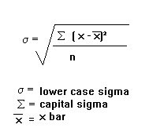

(Capital sigma means to sum the difference between each observation and mean squared.)

**Step 2.4:** Recalculate the t multiple from exercise 1 using the sample size in this question and assign it to a variable.

**Step 2.5:** Calculate 95% confidence interval limits using the formula given at the start of the lab. The confidence interval should look like (smaller number, bigger number).

**Exercise #3 (1 point, .25 points each)**

Using appropriate string operations and methods, correct the typological errors in the following sentences (1 error type per sentence). Here is a reference for string methods. You must use a **DIFFERENT** APPROACH/METHOD for each exercise. [https://www.programiz.com/python-programming/methods/string (Links to an external site.)](https://www.programiz.com/python-programming/methods/string)

**3.a**. the game yesterday was awesome!

**3.b**. I found the quality of this deliverable to be unacceptible. (Hint: consider using slicing.)

Hint: For c and d below,  consider using (1) .replace and (2) a join combined with .rstrip. There are other possibilities too!

**3.c.** Why- did- someone- type- a- dash- after- every- word-?

**3.d.** Here,are,the,words,in,this,sentence.

**Jupyter Notebook Quality (0.5 point)**

The final 0.5 point for this lab is reserved for evaluating the quality of your Jupyter notebooks, as described in (but not limited to) the introduction to this assignment.